Application Overview:
This web application is followed the layered architecture. The layers consisting Database, Data Access Layer, Data Model Layer, Business Logic Layer, Controls Layer, Presentation Layer the total overview of the application is shown in image1. All Layers will be described in the next sections.
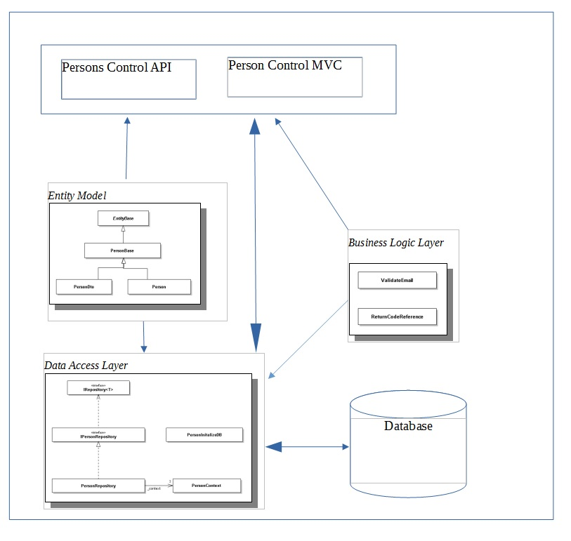
Image 1: Application Architecture

Application Flow:
As shown in image1, the application consists of layers and modules. The application flow is shown in image2.

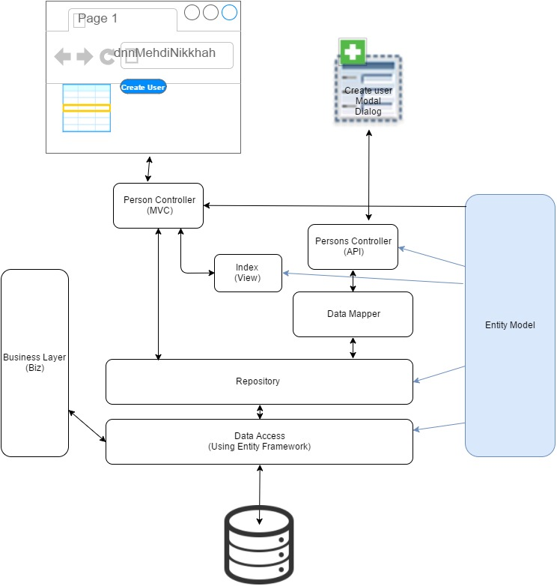
Image 2: Application Architecture

Database Layer:
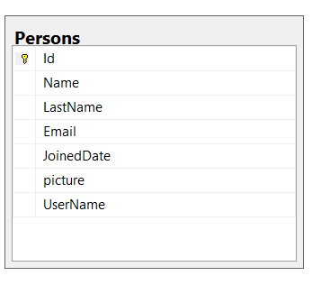
Image 3: Database Person Table
In the current project, Microsoft SQL Server 2014 is used. This database includes two tables of person and MigrationHistory. (image3)
Data Access Layer:
For the DAL layer, Microsoft Entity Framework is used to manage CRUD operations. All code is implemented in the DnnMehdiNikkhah01.DataAccess class library. The repository pattern is implemented in this layer.

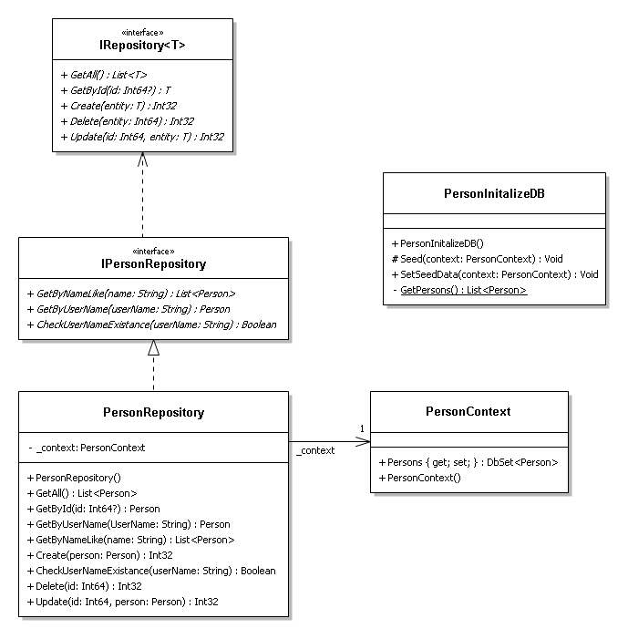
Image 4: Data Access Layer

Entity Model Layer:
This layer includes entity model classes that represent database tables. ComponentModel.DataAnotation and ComponentModel.DataAnotation.Schema namespaces are used to describe the tables and data constrains by attributes. All code is implemented in the DnnMehdiNikkhah01.EntityModel .Net class library.
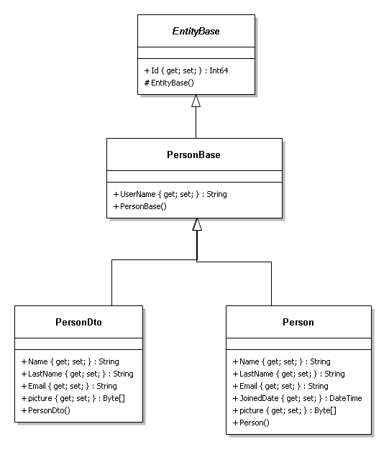
Image 5: Entiy Model
Business Logic Layer
In this layer all business logics and rolls for the application domain are defined, such as checking Email format or the return codes. The layer is implemented in the DnnMehdiNikkhah01.Biz .Net class library.
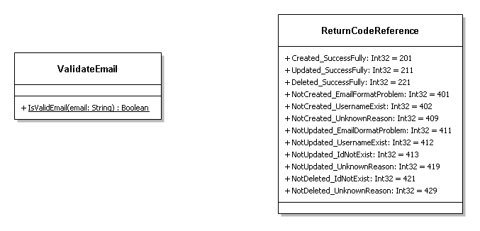
Image 6: Business Layer
Service Layer:
Web API is used and implemented in the DnnMehdiNikkhah01 which is the start up project of the solution. The PersonsController.cs contains the web API class, that is located in Controller/Api folder of the project. The only used action is POST HTTPAction.
User Interface Layer:
MVC controller contains the index action to handle the end user requests and provide the corresponding view which return the user list. The PersonController.cs contains the index actions is located in the Controller folder of the project. The Inverse Injection Pattern is used in Person Controller.
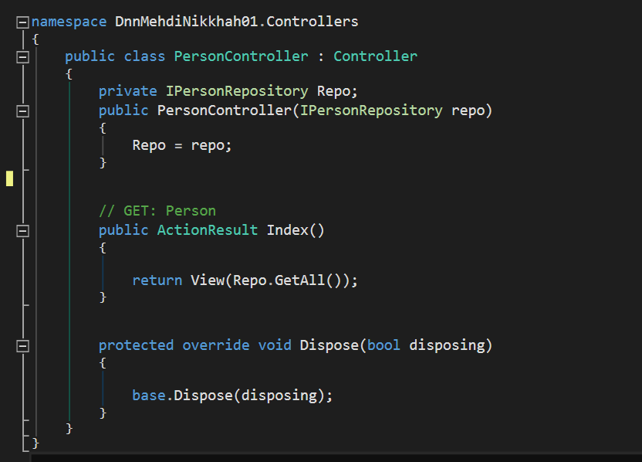
Image 7: MVC PersonController
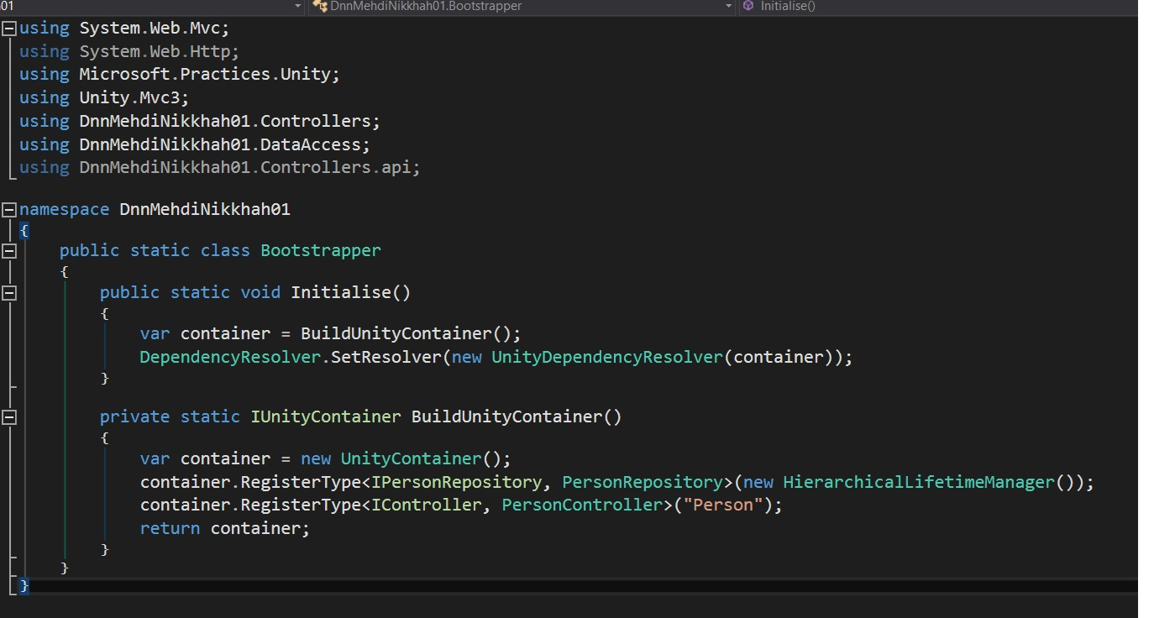
Image 8: Inverse Injection (dependency Injection using Unity)
JQuery
For the UI layer a combination of Razer formatting and Jquery code is used. The related views are located in View/Person folder of the project. By using Jquery browser is capable to insert new user async, update list, sort and search Names.
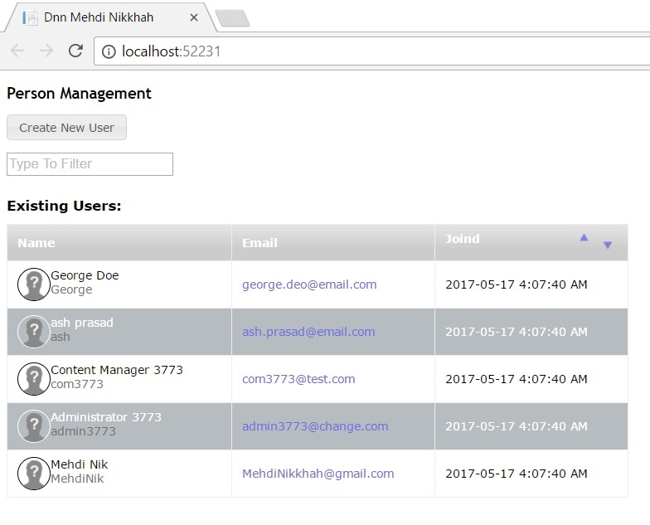
Image 9: User List

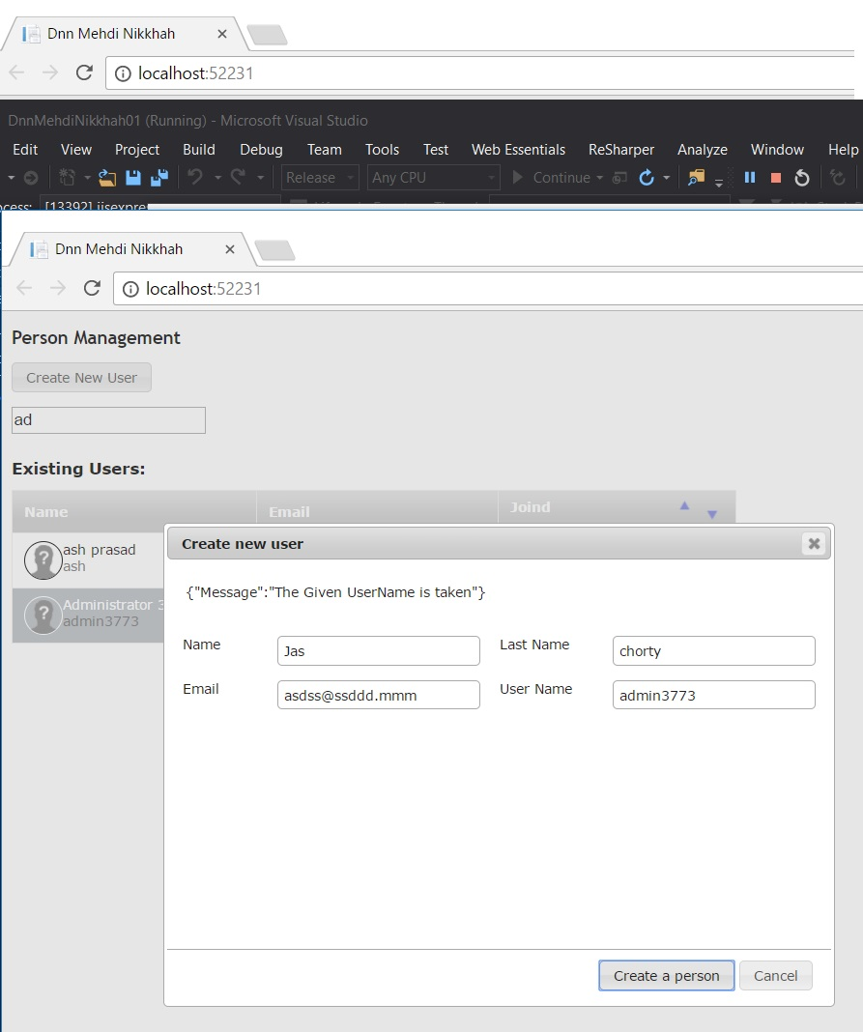
Image 10: Create User Modal Dialog

